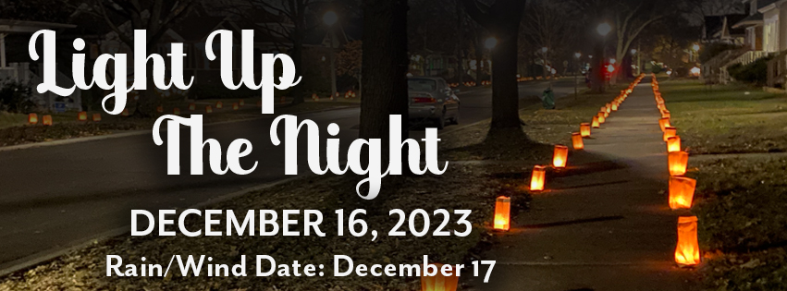

Our community is pulling together and lighting luminaria on the evening of December 16th, we would love our block join in the beauty of light and community!

We will be assembling and then setting out luminaria* on every other corner of each square sidewalk section and then lighting them at 4:15pm (sunset). All bags will be removed from the sidewalk the following morning. Please let us know if you prefer not to have luminarias placed on the sidewalk in front of your home.

Our block captain is <NAME> and will be coordinating the effort. Please contact <NAME> at <NUMBER> to volunteer to help on the 16th. We will work together to set up times for assembly, setup and take down. (If it is too rainy or windy we will set up on the 17th)

Please join us for a beautiful evening walk around the neighborhood, safely masked and distanced, to connect with our neighbors.

To keep updated and for more information join the Facebook Group – Light Up the Night-Oak Park https://www.facebook.com/groups/lightupnight

Luminaries are paper bags weighted with sand, and a candle inside
https://flicluminaries.com/content/14-luminary-history

