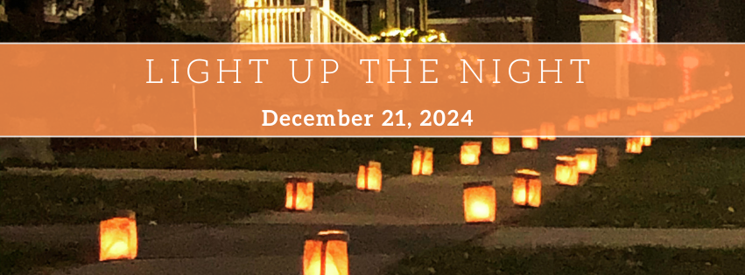

**Our community is pulling together and lighting luminaria on the evening of December 21st, we would love our block join in the beauty of light and community!**

We will be assembling and then setting out luminaria* on every other corner of each square sidewalk section and lighting them at 4:15 pm (sunset). All bags will be removed from the sidewalk the following morning. Please let us know if you prefer not to have luminarias placed on the sidewalk in front of your home.

Our block captain is <NAME> and will be coordinating the effort. Please contact <NAME> at <NUMBER> to volunteer to help on the 21st. We will work together to set up times for assembly, setup, and takedown. (If it is too rainy or windy we will set up on the 22nd)

**Please join us for a beautiful evening walk around the neighborhood to connect with our neighbors.**

To keep updated and for more information join the Facebook Group – Light Up the Night-Oak Park <https://www.facebook.com/groups/lightupnight>

Luminaries are paper bags weighted with sand, and a candle inside  
https://flicluminaries.com/content/14-luminary-history